**Chadel Dowridge**

**11/18/24**

**Oracle E-Business Inventory**

**Question #1**

1. What is the Oracle Inventory module?

The oracle inventory module is a module that stores,manages,tracks, and even report items, and inventory levels and other important components for businesses so they are used for better business practices across the world.

**Question #2**

2.With you User id switch to: **Vision Operation Inventory**. Responsibility.

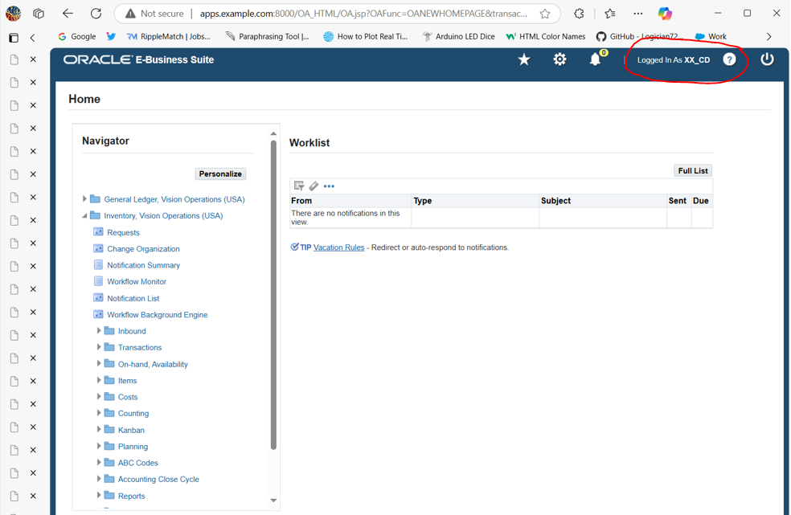

**Question #3**

3.Choose **VI Inventory Org & Find the master Items.**

**First step i did was follow this path**

**PATH: Inventory > Items > Master Items >**

**Second step i did was us Ctrl + f11 to fill the payment sources then i was able to get this screen of showing item number 03_item**

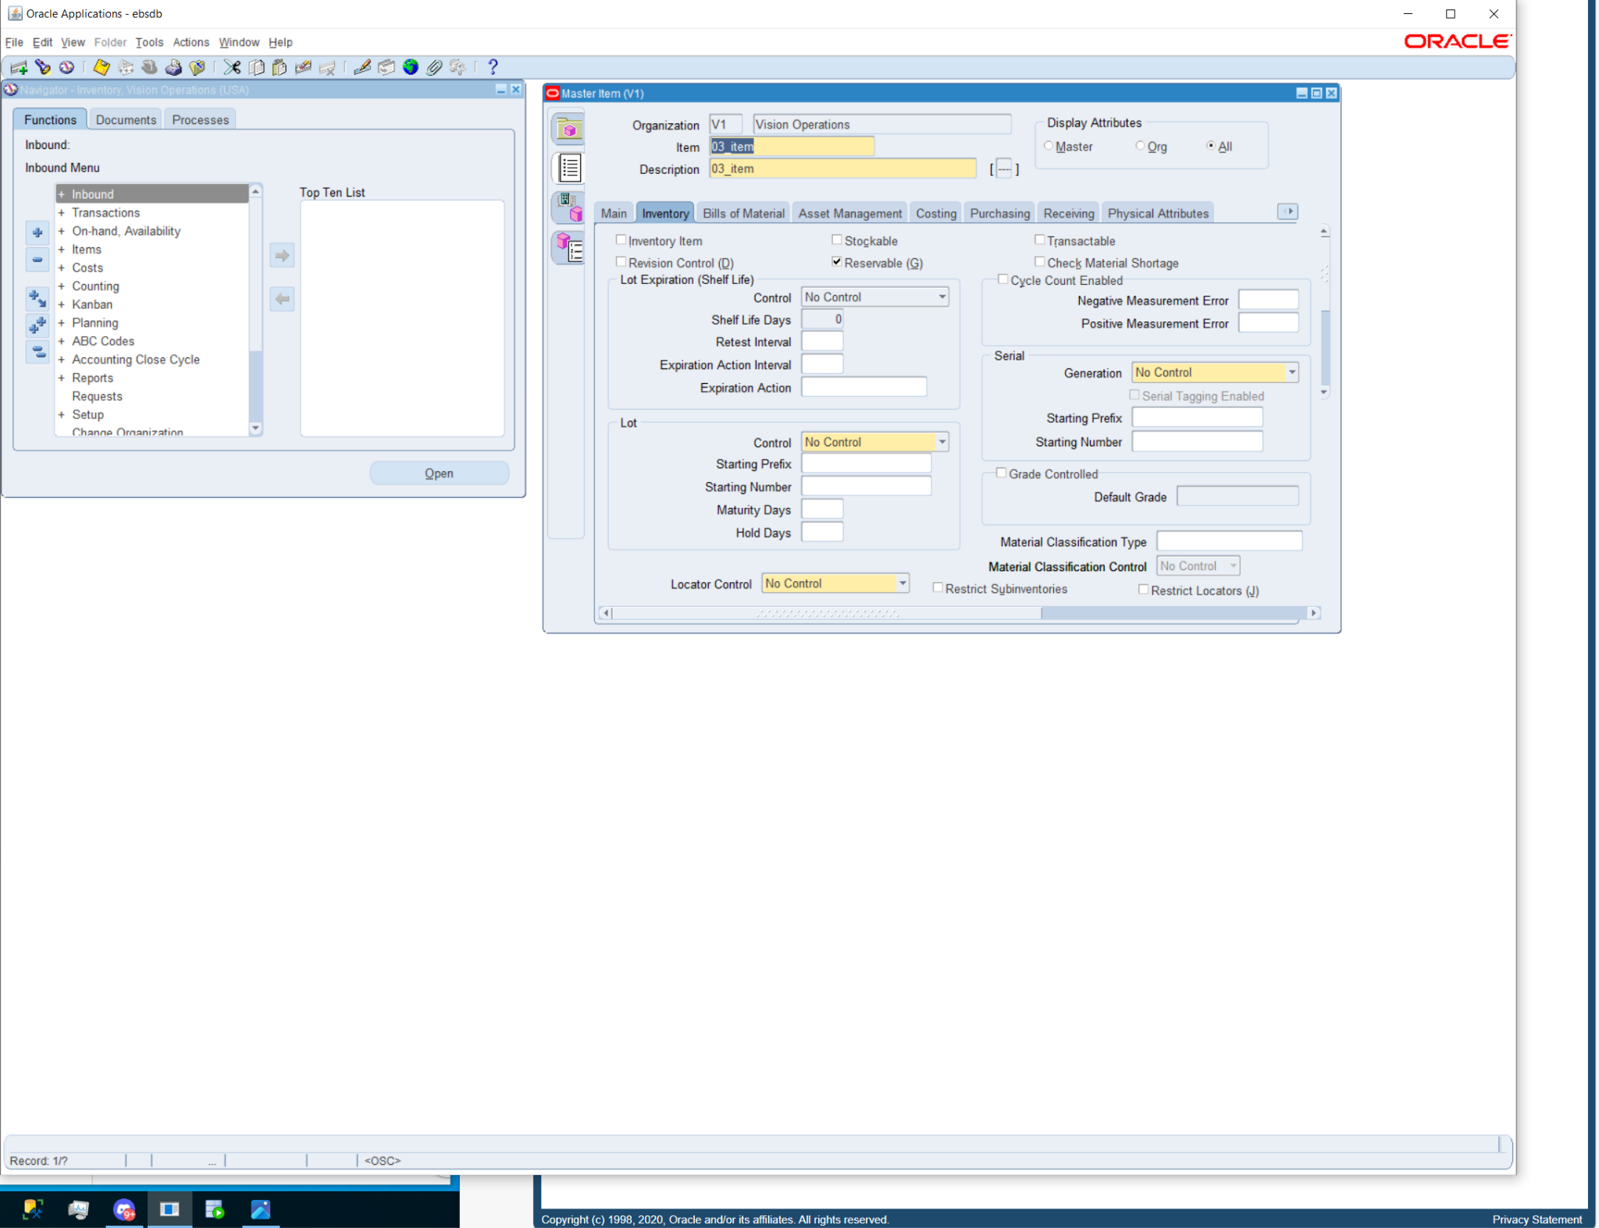

**Question #4**

4.Take any Item & assign the same Item for all the **Inventory Org.**

**First step i did was follow this path**

**PATH: Inventory > Items > Master Items >**

**Second step I did was click the Assign All button to assign the item.**

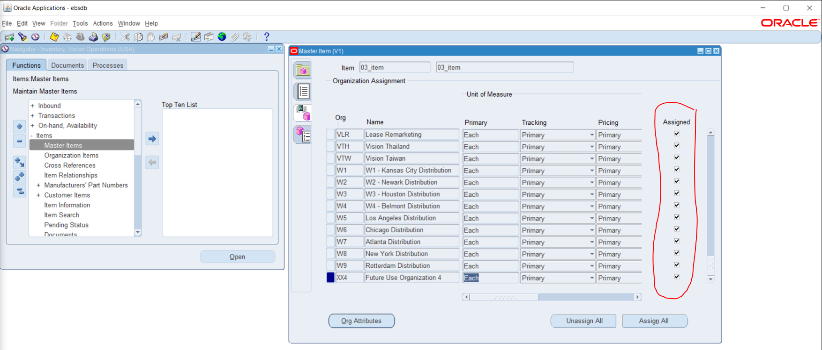

**Question #5**

5. And Un assign the same Item for all the **Inventory Org.**

**First step i did was follow this path**

**PATH: Inventory > Items > Master Items >**

**Second step I did was click the UnAssign All button to un-assign the item.**

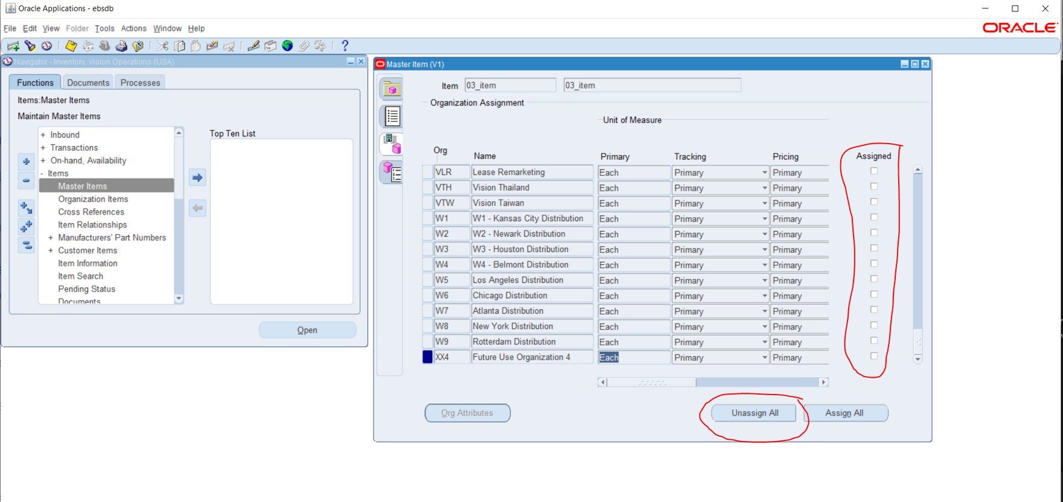

**Question #6**

6**.** Any of the existing Item [VI Inventory org] Check the on-hand quantity.

**First step i did was follow this path**

**PATH: Inventory > On-hand Quantity >**

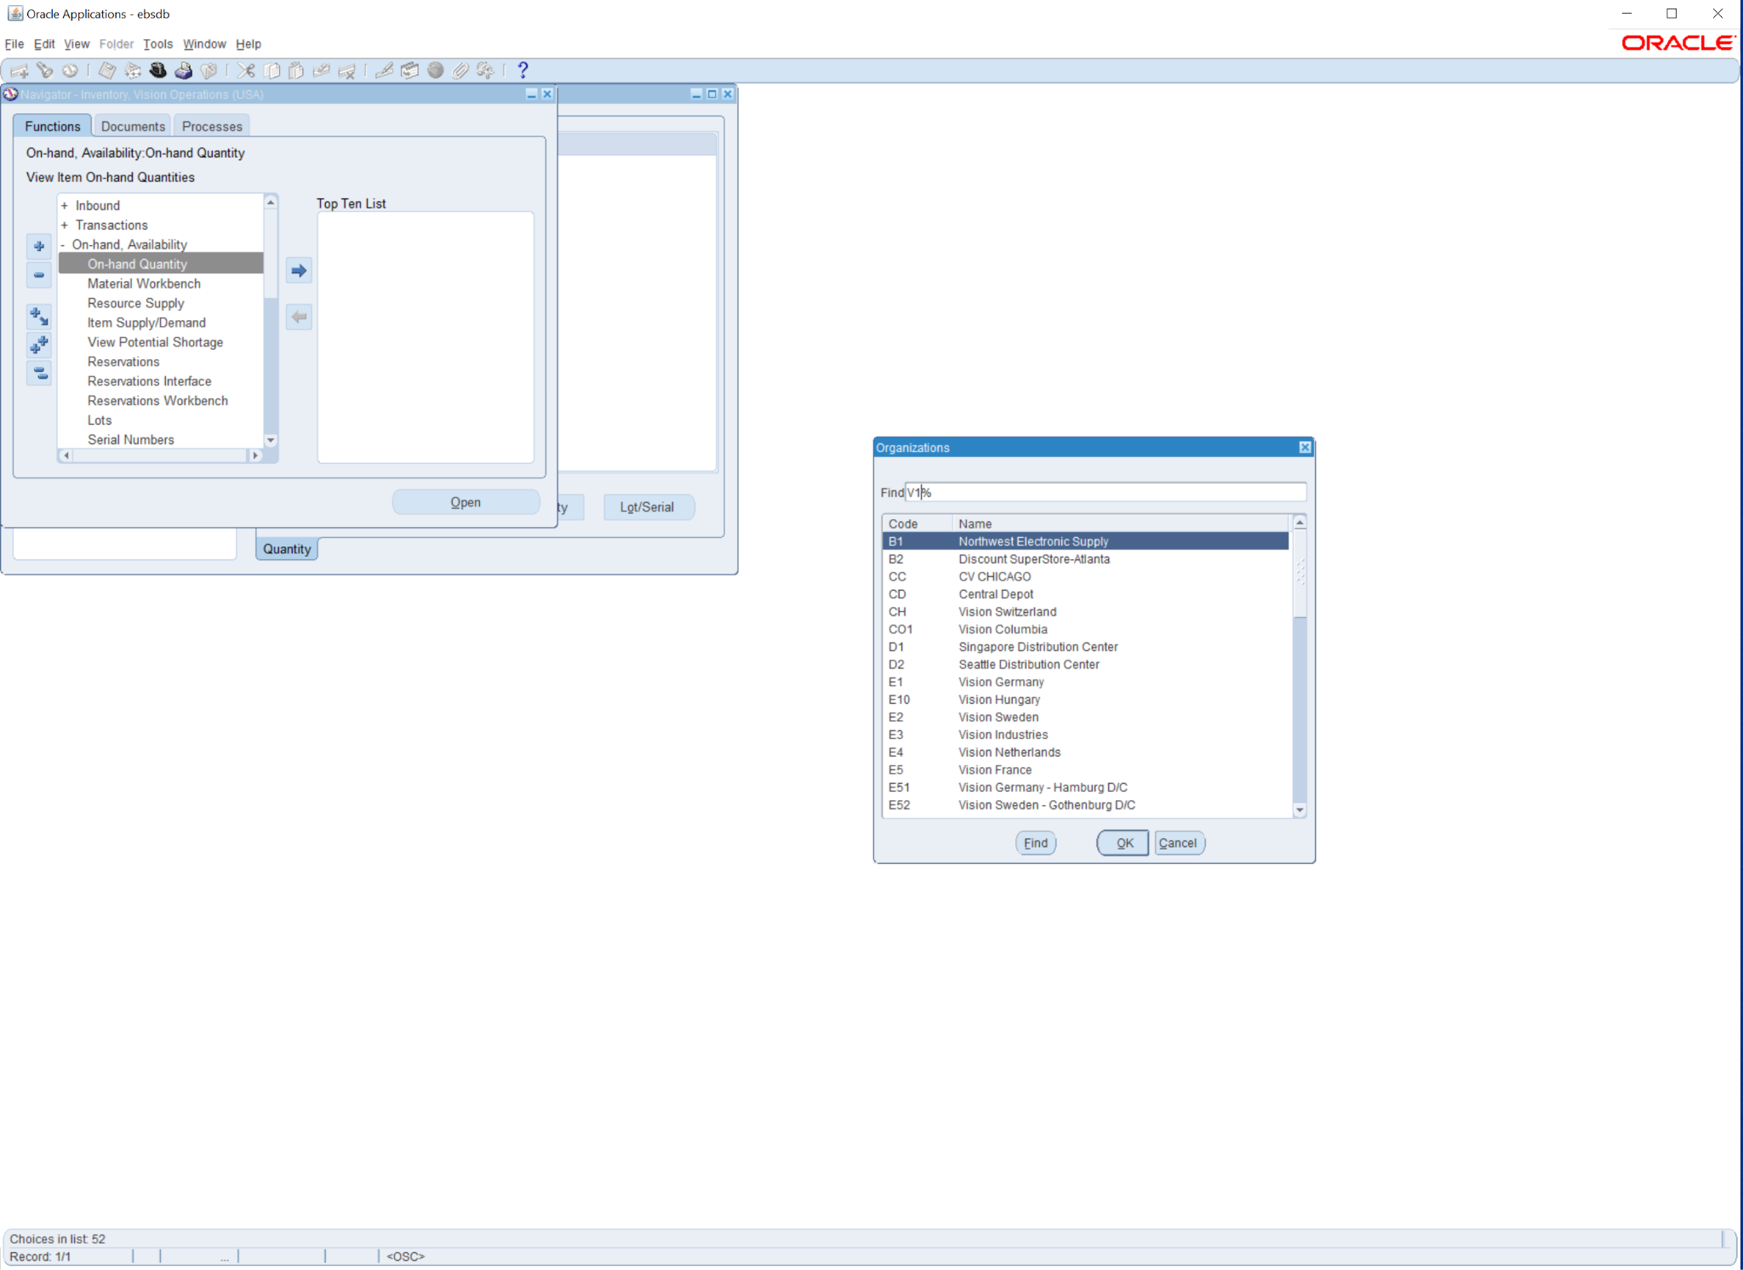

**Second step I did was put in the organization to**

**V1 (Vision Operations)**

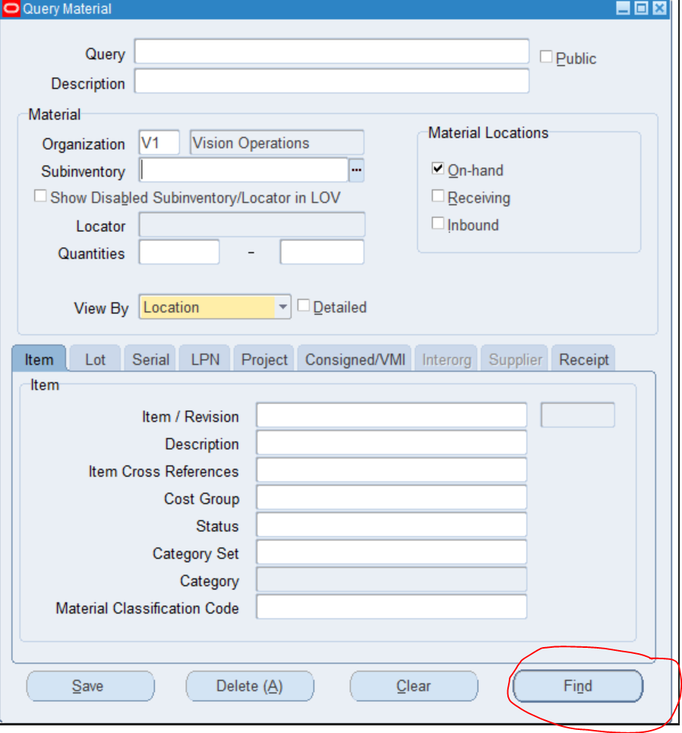

**From here i clicked find the material workbench where i clicked on Availability**

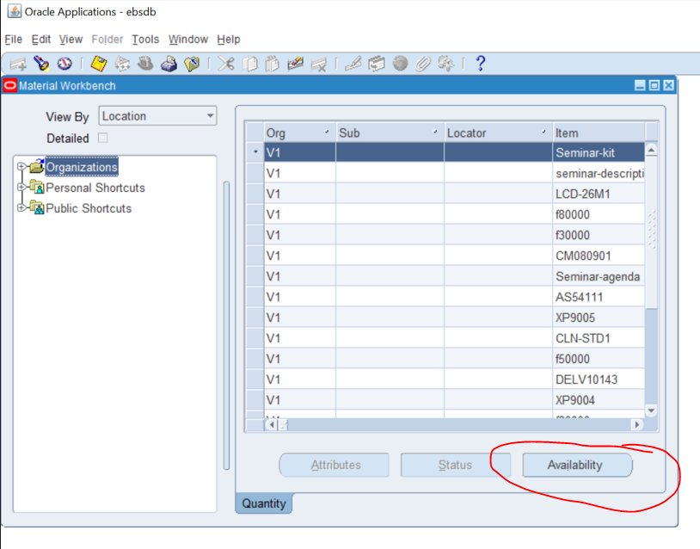

**From here by clicking Available it showed the Total Quantity, Available to Reserve, Available To Transact,**

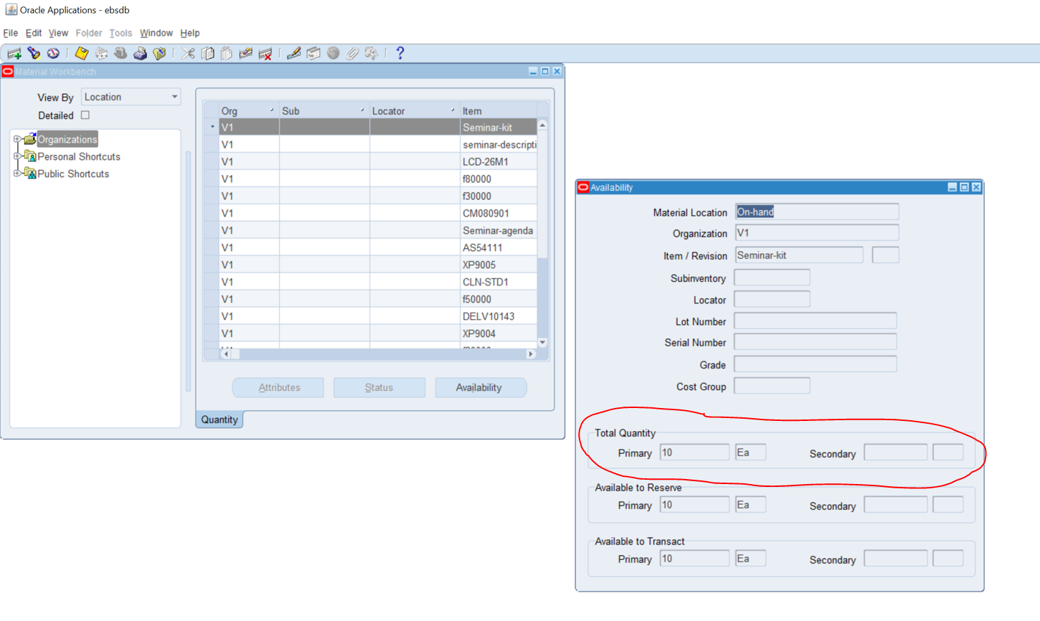

**Question #7**

7. Unit of Measure (UOM)... with Navigation show where UOM has been defined.

**First step i did was follow this path**

**PATH: Inventory > Setup > Units of Measure > Units of Measure**

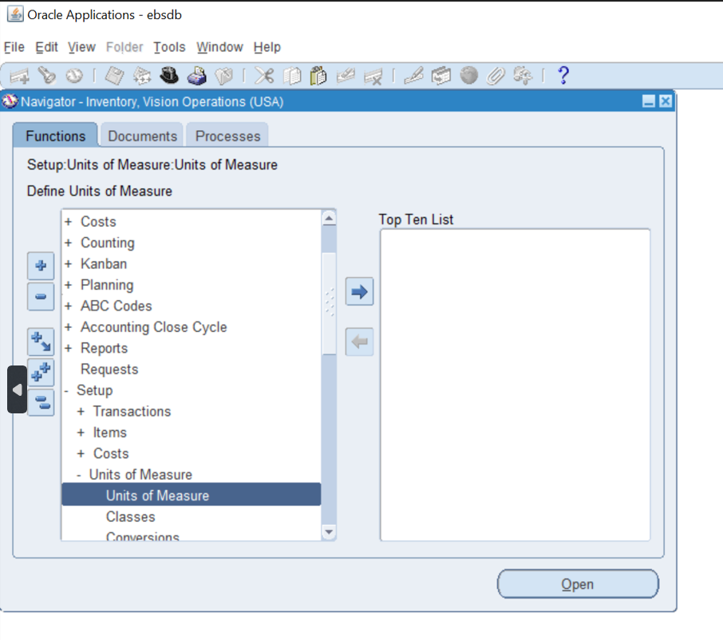

**Using this path this is where UOM is defined.**

**Question #8**

8. How do you create a new inventory item?

**First step i did was follow this path**

**PATH: Inventory > Items > Master Items**

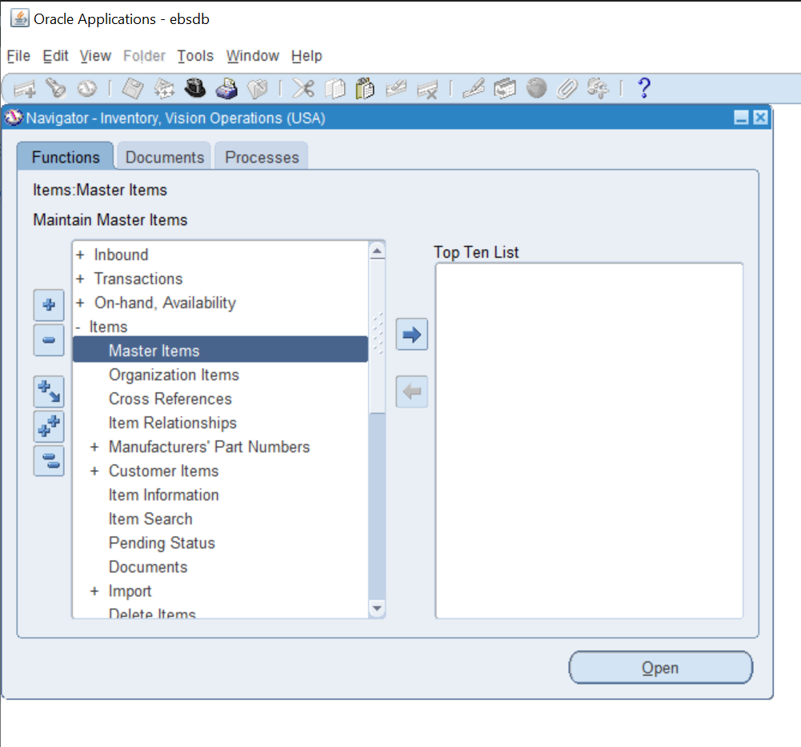

**From here i typed in V1 (Vision Operations)to select the correct Organization to work from**

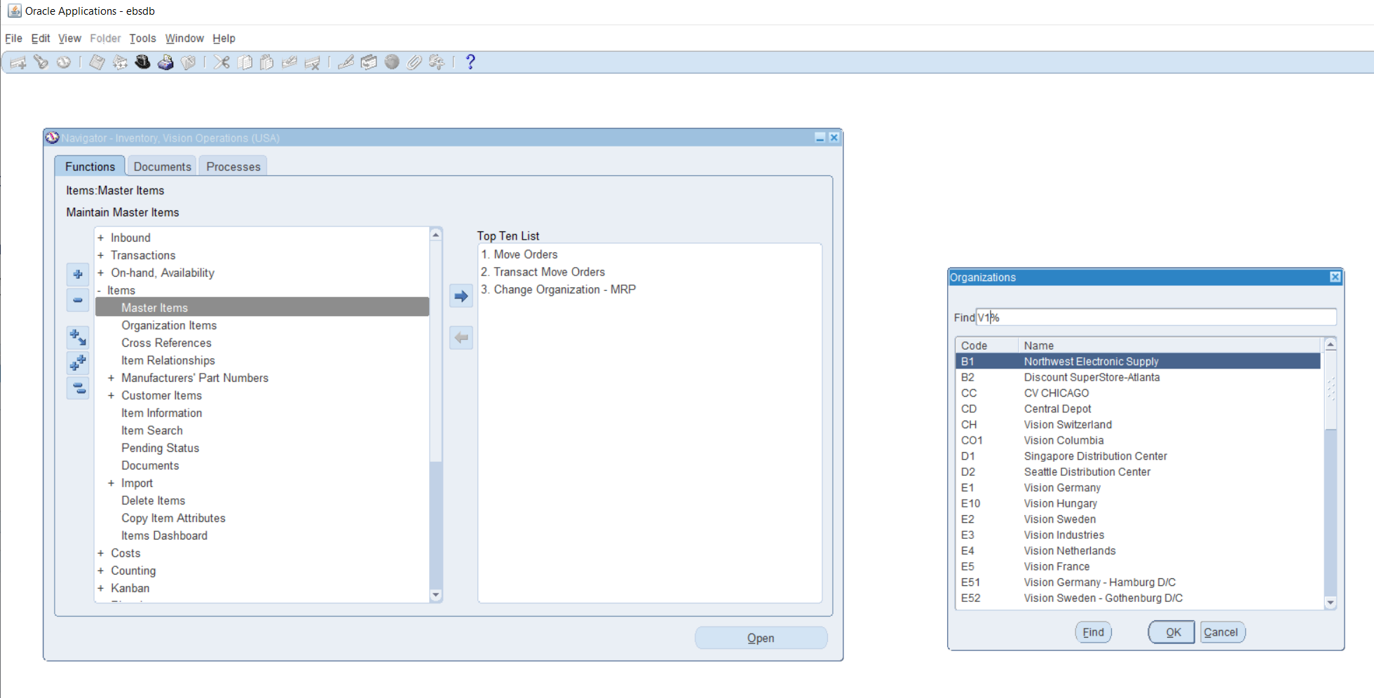

**From here you can create an item from the item line.**

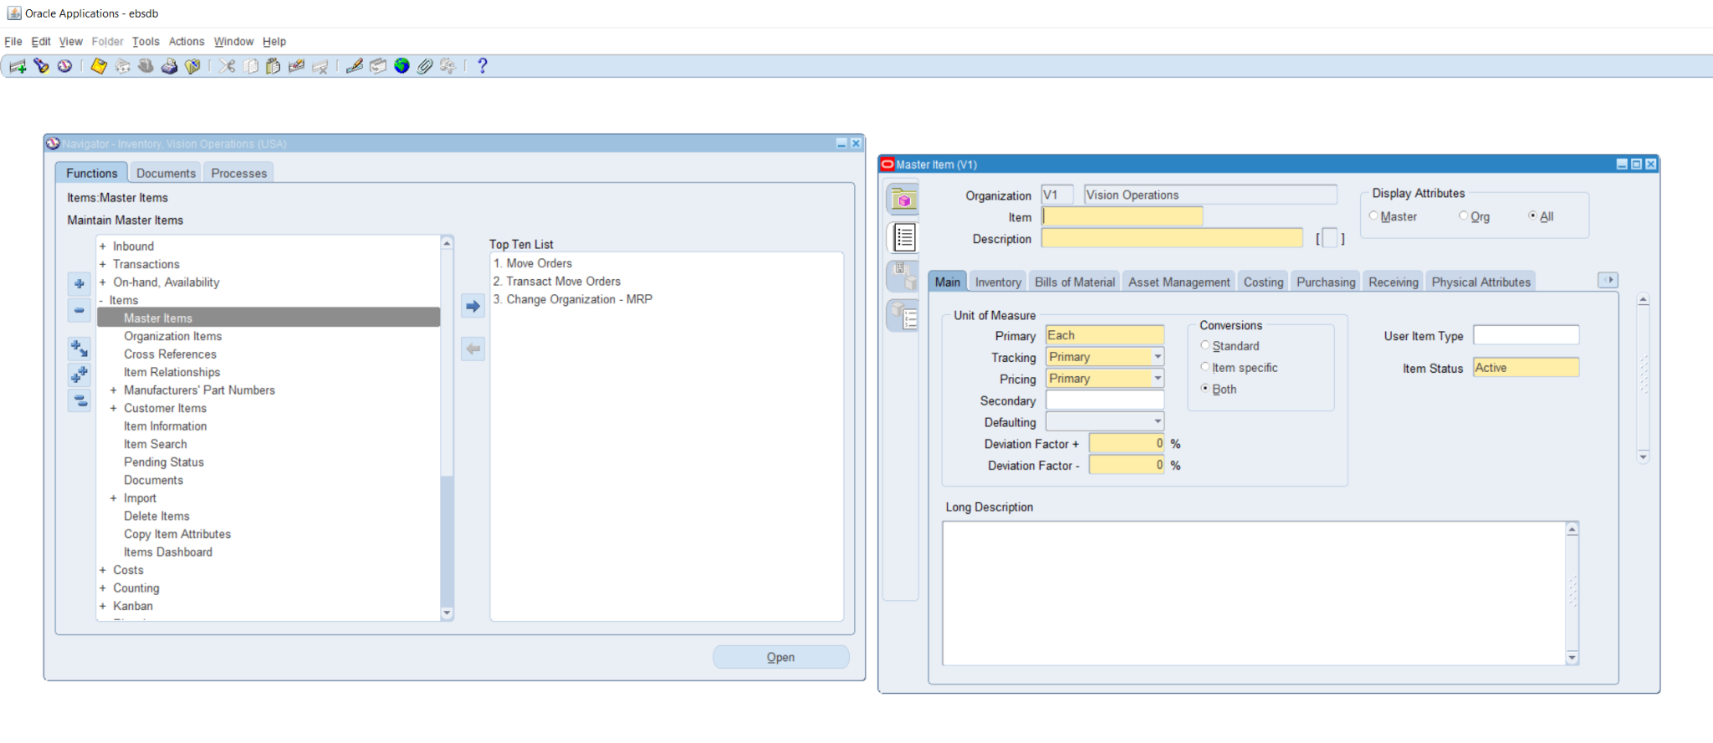

**Question #9**

9. How to run Inventory Valuation Report?

**First step i did was follow this path**

**PATH: Inventory > Requests**

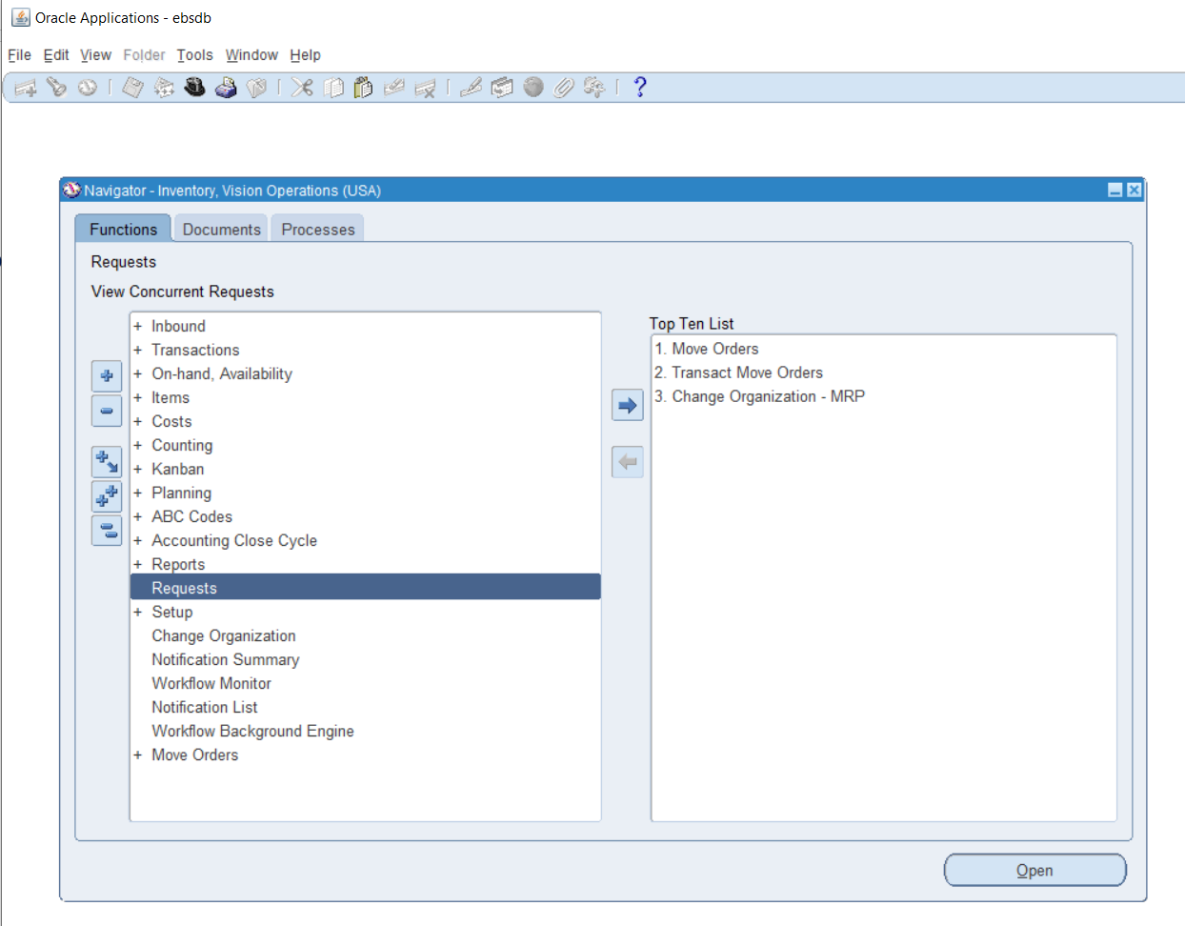

**From there i clicked on find to see all of the data so i am able to see the Valuation report**

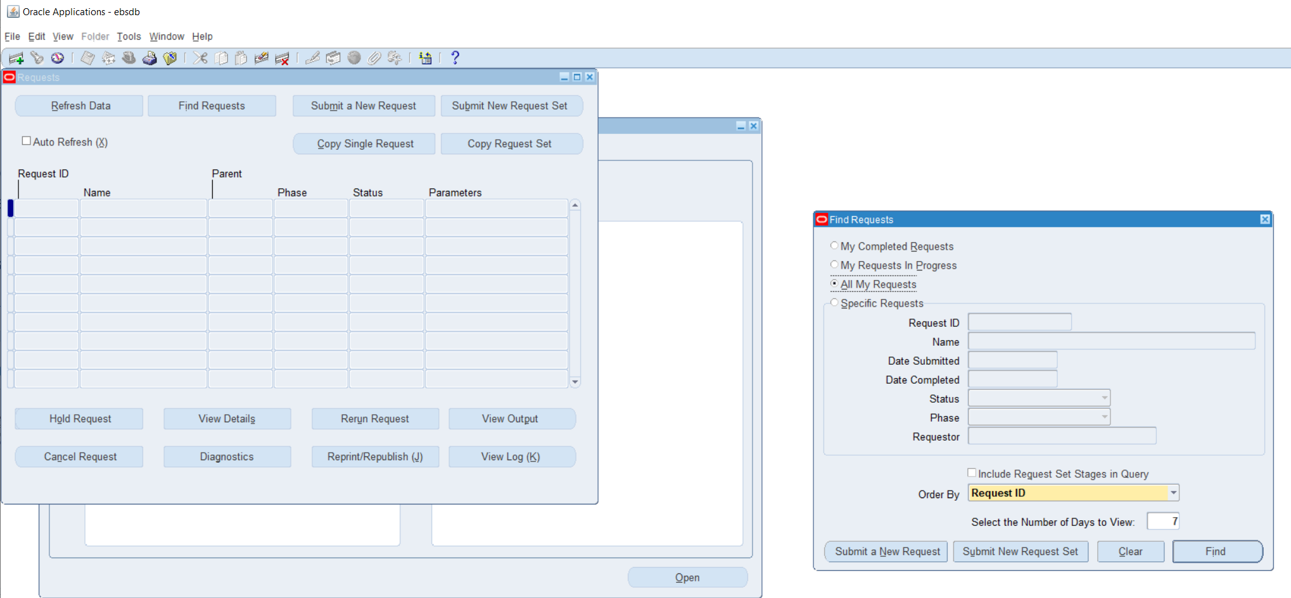

**From here when i clicked on find it showed the report**

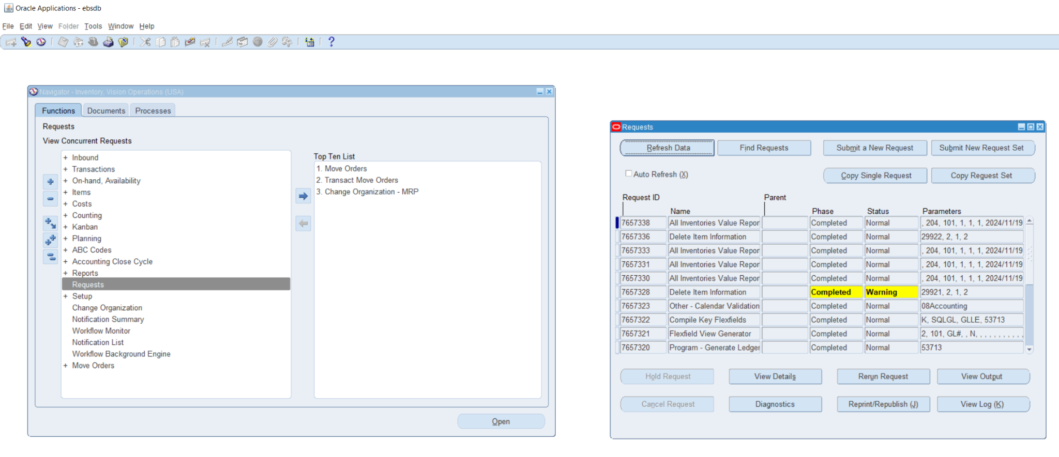

**From here it shows the Valuation Report.**

**Question #10**

10.How to change Inventory Organization in the Current responsibility.

**First step i did was follow this path**

**PATH: Inventory > Change Organization**

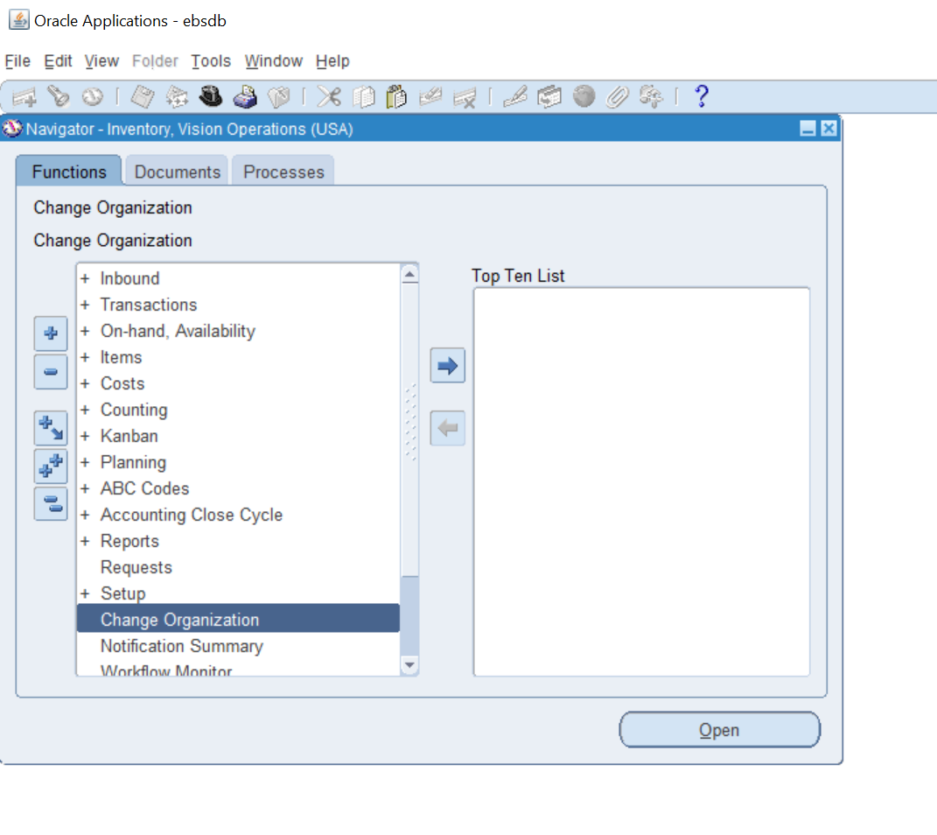

**From here this is how you would change your organization**

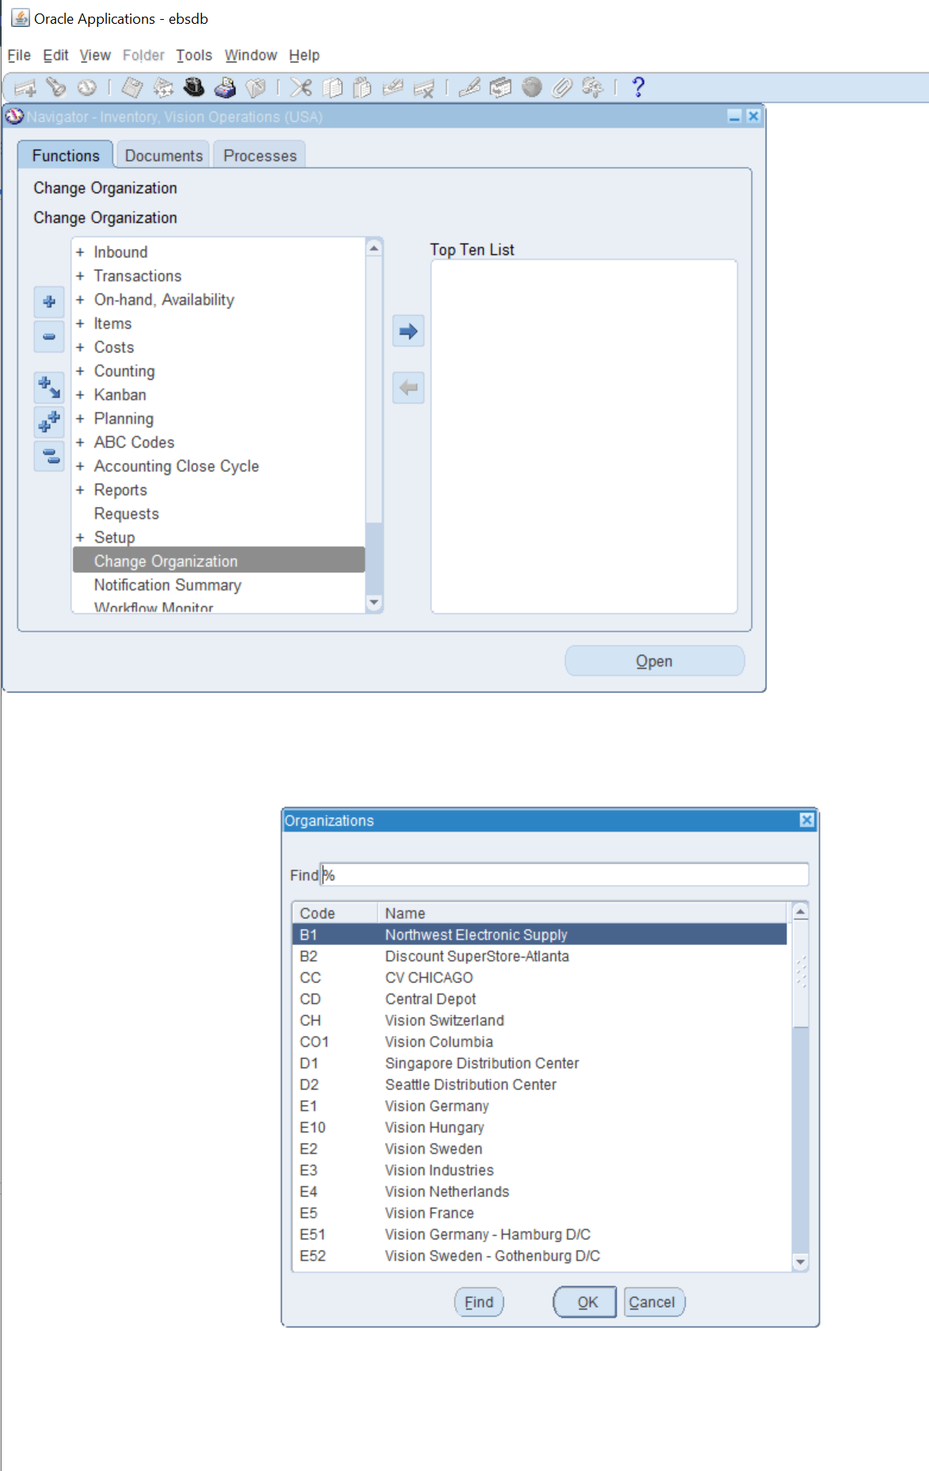

**Question #11**

11. What is **Master Data** in Oracle Inventory?

**Master data in Oracle Inventory is core information in responsibilities for business for example items are considered master data because they are made to be stored in the inventory.**

**Question #12**

12.Show the existing ORG with navigation.

**First step i did was follow this path**

**PATH: Inventory > Setup > Organizations > Organizations**

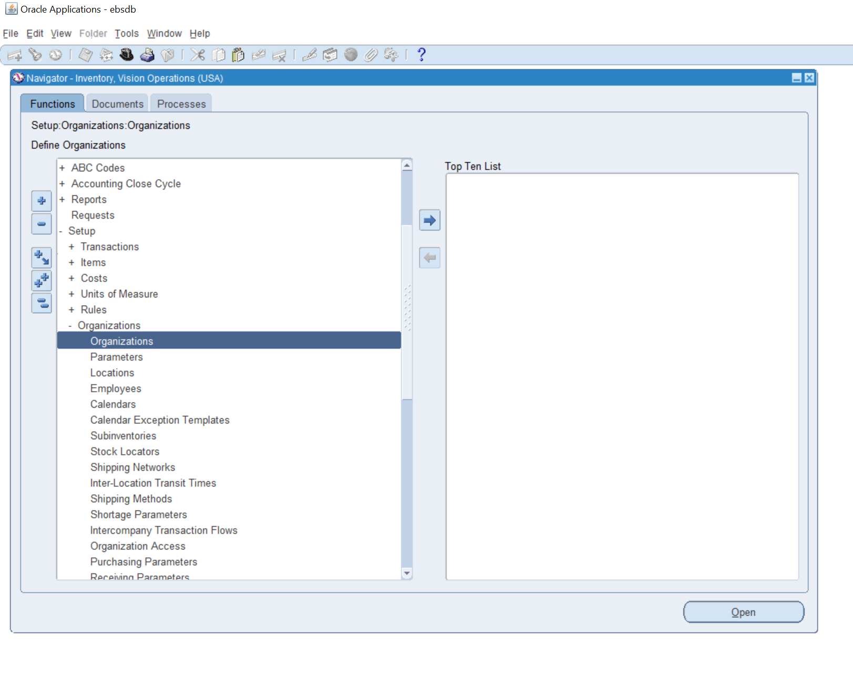

**second step i did was find the correct name which is Vision Operations**

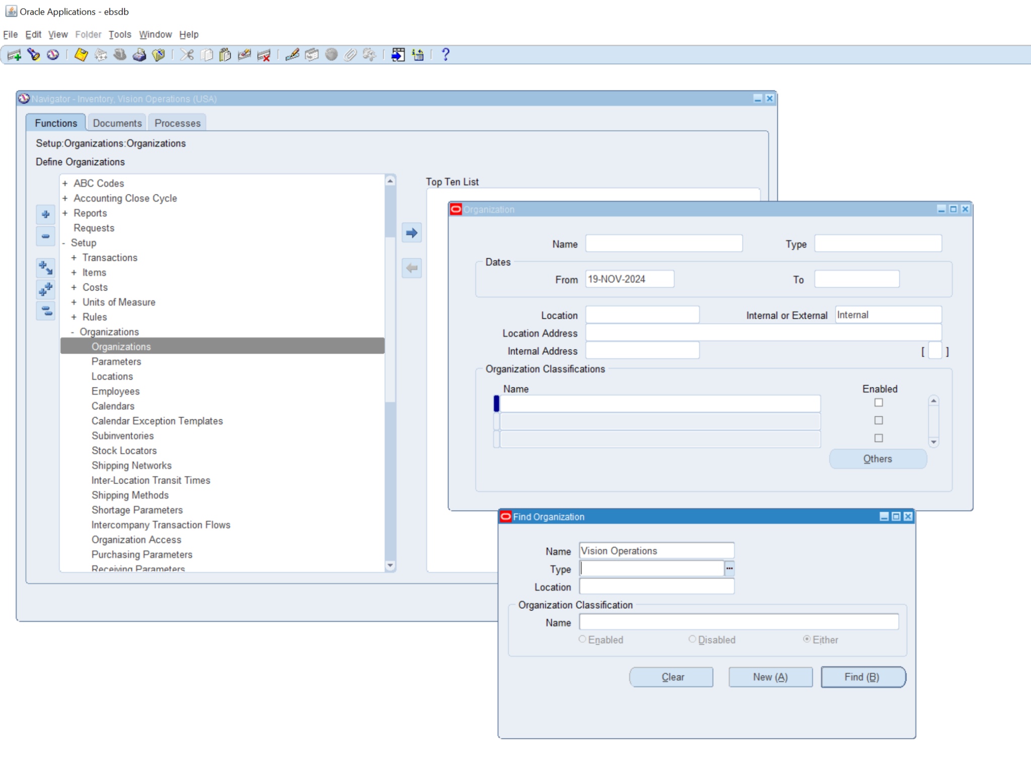

**Third step is that i filled the organization with the same name as the original field so i was able to see the ORG**

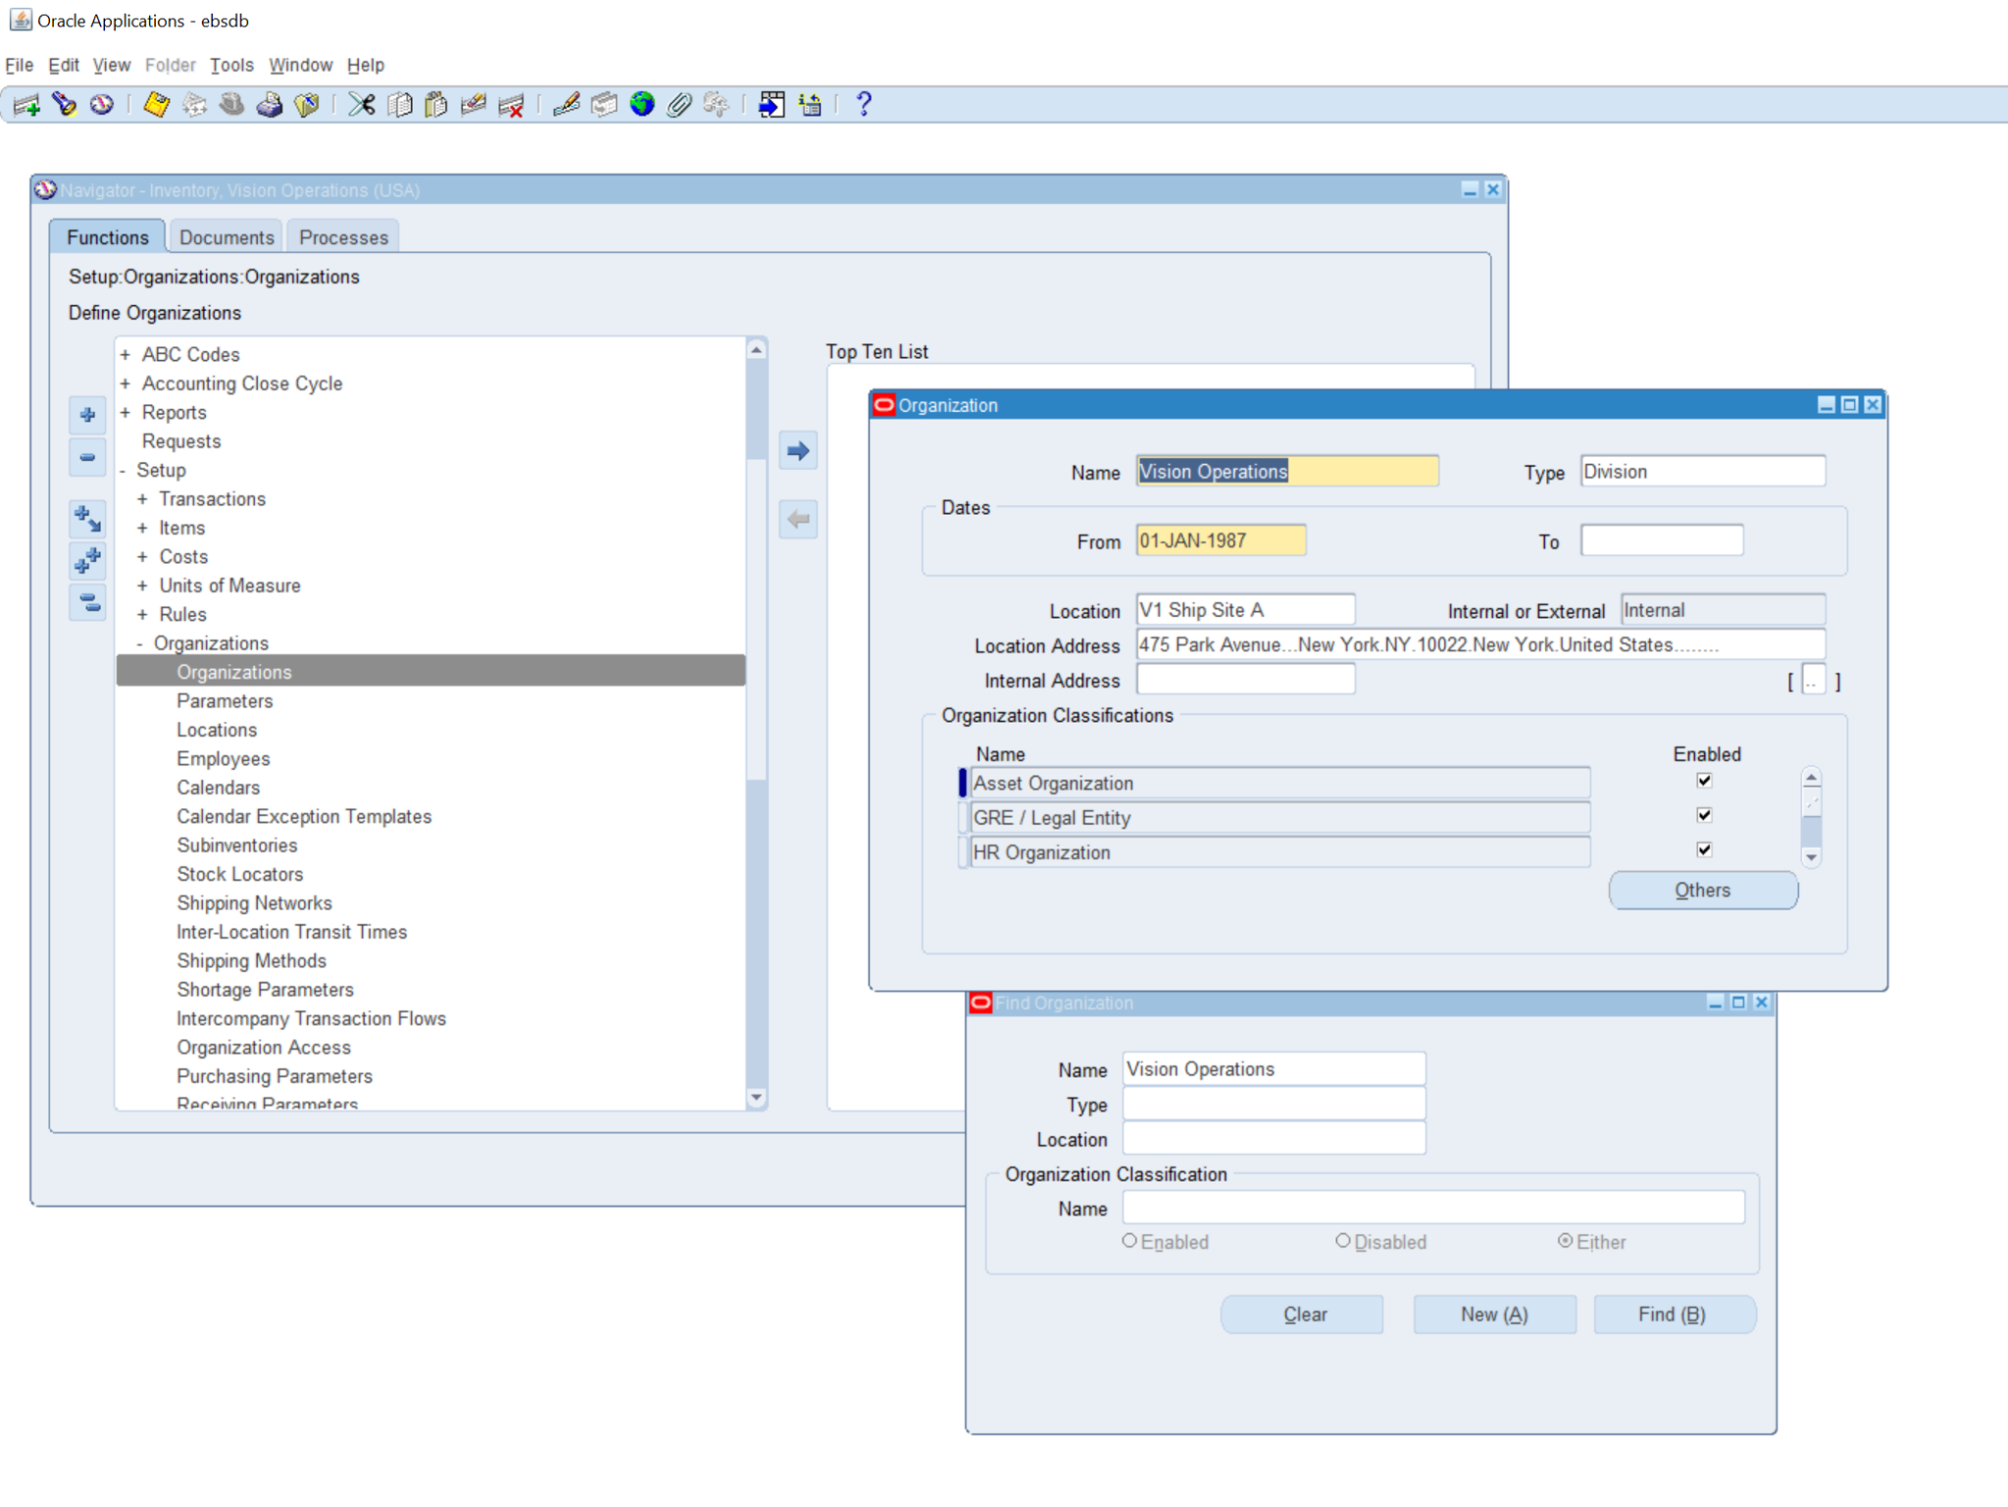

**Question #13**

13: You can manage only finished goods in **Oracle Inventory**? [True/False]

False, this is false because in Oracle Inventory you can store more thing than just finished goods in a business setting, for example spare parts at a car shop would need to store each part different because of size and overall parameters to function correctly

**Question #14**

14. You need to create an item before performing inventory transactions **[True/False].**

This is True because you cannot have an inventory when creating items first.

**Question #15**

15.Sub inventories are optional in Oracle Inventory. **[Ture/False].**

False this answer is false because its a mandatory action because each transaction has to have to be manageable, organizable which makes the sub inventories mandatory.